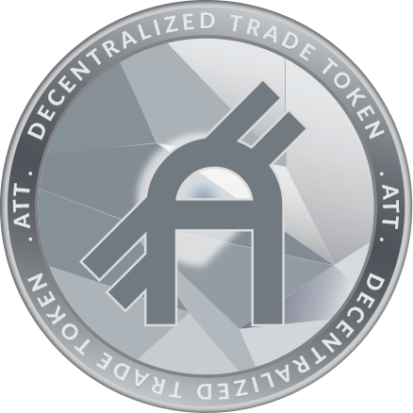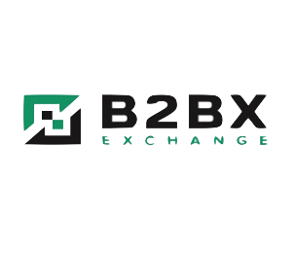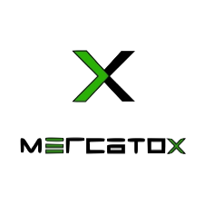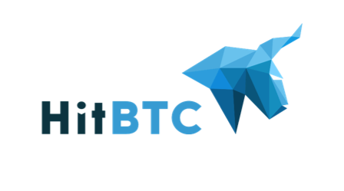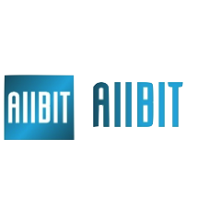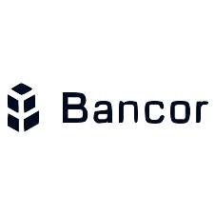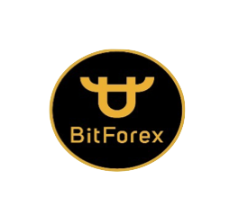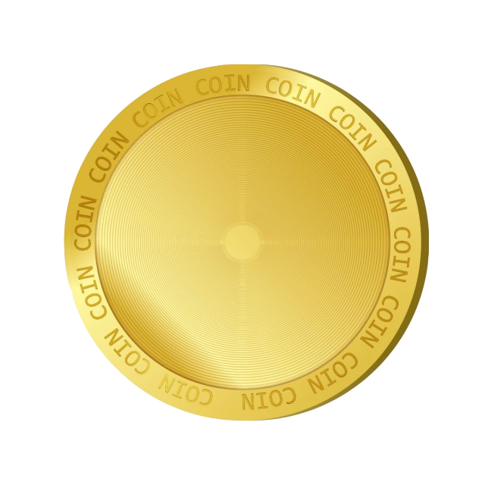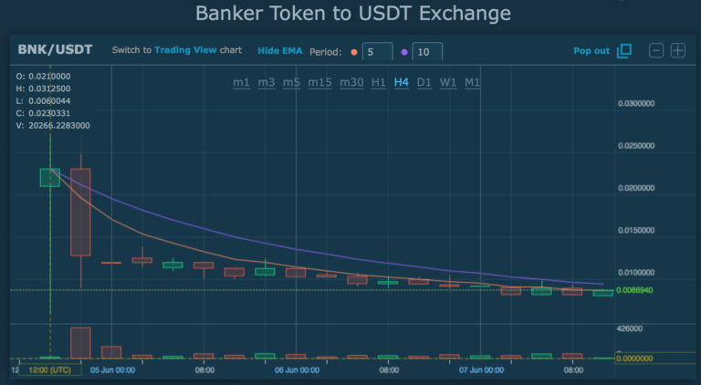

約50分の１の資金を使って取引をしている

証拠金(=口座残高)の何％を取引に使っているか

All Gold Members benefits are applied

* The price of ATT varies depends on each stage up to ICO.

BUY

56,000 ATT

EARN

19,000 ATT free

BUY

22,500 ATT

EARN

7,500 ATT free

BUY

11,500 ATT

EARN

3,500 ATT free

・35% Discounts on Exchange

・VIP Robots and AI Engine

・Free Tools and Signals

・OTC Crypto Exchange

・Voting

・35% Discounts on Exchange

・Free Robots and funds

・Free Tools and Signals

・35% Discounts on Exchange

・VIP Robots and AI Engine

・Free Tools and Signals

・OTC Crypto Exchange

・Voting

SILVER

GOLD

PLATINUM

ATT TOKEN HOLDERS

EX)

* Deposit $10,000 for FX
* Purchase 22,500ATT token

→ Get 7,500ATT on free

$5,000

$10,000

$25,000

FX DISCOUNT

10%

FX DISCOUNT

25%

FX DISCOUNT

35%

**TOKEN**

**BENEFITS**

15,000 ATT

30,000 ATT

75,000 ATT

**TOKEN**

**BENEFITS**

**TOKEN**

**BENEFITS**

**Exchange Listing**

**Token price transition to listing**

TOKEN SUPPLY:　200,000,000

**Annual trading volume of the stock market is $ 77.6 trillion**

**Daily trading volume of the exchange market is $ 5 trillion**

**Daily trading volume of virtual currency market is $ 24.2 billion**

**Market target of ATT token**

ATT Token is a utility token on the ERC-20 (Ethereum blockchain), and the trading fee discount that can be earned by holding this token brings great value to global investors / traders. In addition, discounts according to your trading and exchange needs, copy trading systems and funds offered by A2TRADE are 100% transparent by using smart contrast technology.

…

…

…

…

…

…

CROWD SALE:　130,000,000 ATT TOKENS

$0.23

$0.32

$0.22

$0.26

$0.21

$0.25

$0.19

$0.24

http://www.a2trade.io

There is a risk of

selling out after listing

* The number changes every ICO stage.

* See results of research team at Boston College in Massachusetts, USA

ATT Token

Other Coin

About 182%

on average

Comparison Other Coins and ATT Token of Profit and Risk

Benefits

Investors who have purchased tokens during Pre ICO may start selling all at once and may fall below the ICO price if their currency expectations have not increased by just before listing

When listing, the fall of the currency value by selling away

Risk of ICO (Initial Coin Offering)

Company

This is a mechanism that can earn profits by holding coins, so the risk of selling out is low

VS

About 152%

* In the case of ATT Token, the purpose is not to make a profit by trading coins, but to obtain many benefits by holding the coins and to make a profit in the long run, because it prevents the decline in value after listing common to other coins.
* If many investors join A2TRADE, the price of the coin has great potential to rise.

Price fluctuation forecast after listing of ATT Token

Bankera example

Ref：https://booksmile.net/bankera-listed/

Sell